KS01 – Create Cost Center

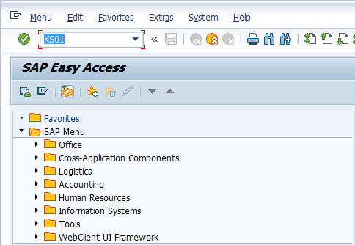

- Input KS01 in Transaction Box and press Enter key

Set Controlling Area Screen.

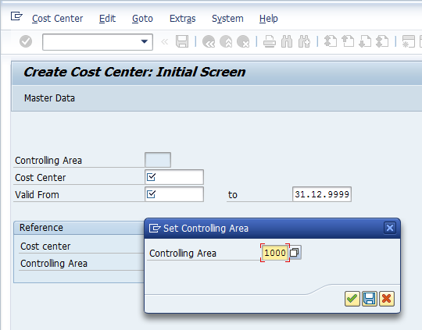

- Controlling Area: Input or select controlling area with the help of F4 key
Press Enter key

Create Cost Center Initial Screen.

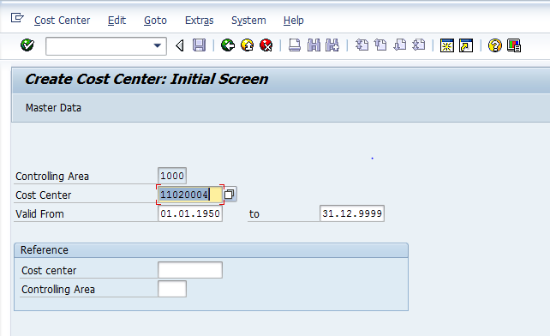

- Cost Center: Input cost center to be created
- Valid From: Input or select valid from date with the help of F4 key (i.e. cost center will be valid from this date)
- to: Input or select valid to date with the help of F4 key (i.e. cost center will be valid till this date)
Press Enter key

Create Cost Center Basic Screen.

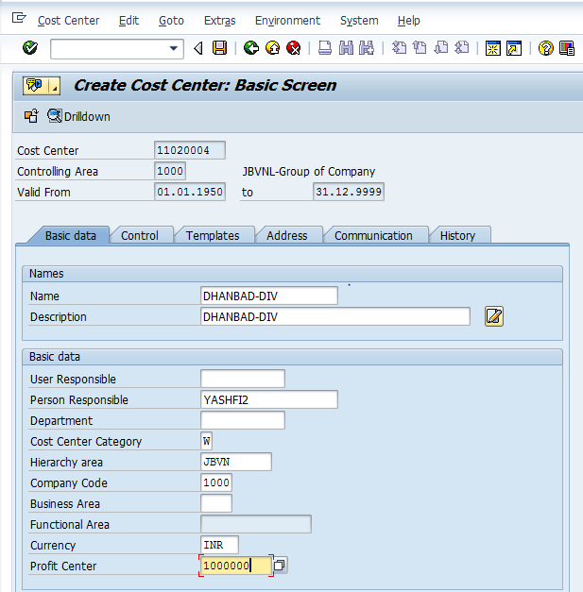

- Name: Input cost center short name
- Description: Input cost center long name
- Person Respons.: Input person responsible for respective cost center
- Department: Input department Location Center, Location Center = Cash Book
- Cost Center Category: Select relevant cost center category with the help of F4 key
- Hierarchy area: Select relevant hierarchy area with the help of F4 key
- Company Code: Input or Select relevant company code with the help of F4 key
- Currency: Select relevant currency with the help of F4 key
- Profit Center: Select relevant profit center with the help of F4 key
Click on Save icon or press Ctrl+S keys to save the data.

The cost center has been created message appears at bottom of the screen

Manual End

